ALBANY HIGH SCHOOL
JODI M. COMMERFORD, PRINCIPAL

700 Washington Avenue • Albany, New York 12203 • 518-475-6200 • fax 518-475-6202

City School District of Albany

November 4, 2019

Dear Families:

I am writing to let you know that we have determined that the band and orchestra room in our music wing will remain closed for the rest of the 2019-20 school year due to ongoing concerns about air quality in that room.

A professional mold remediation and environmental services company has been working in the music wing since mold was discovered during the summer. The choral room, faculty offices and three practice rooms were cleared for return to regular use in early October and will remain in use. However, the band and orchestra room will remain closed. That room will be sealed off from the rest of the music wing.

Band and orchestra classes will continue to meet in the auditorium until further notice.

The health and safety of all of our students and staff is a top priority at Albany High School and throughout the City School District of Albany. If you have any questions about this matter, please contact me at (518) 475-6200.

Sincerely,
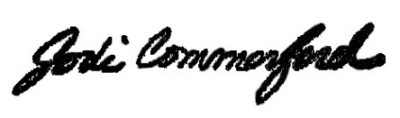
Jodi Commerford
Principal

